TEAM ID : PNT2022TMID24184

PROJECT NAME: PERSONAL ASSISTANCE FOR SENIORS WHO ARE SELF RELIANT

Develop A Web Application Using Node-RED Service

CREATING A FORM

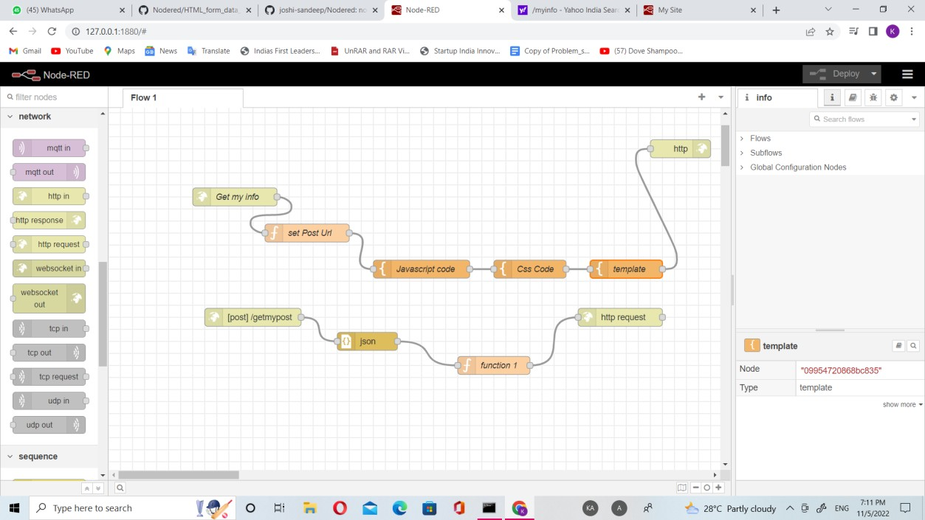

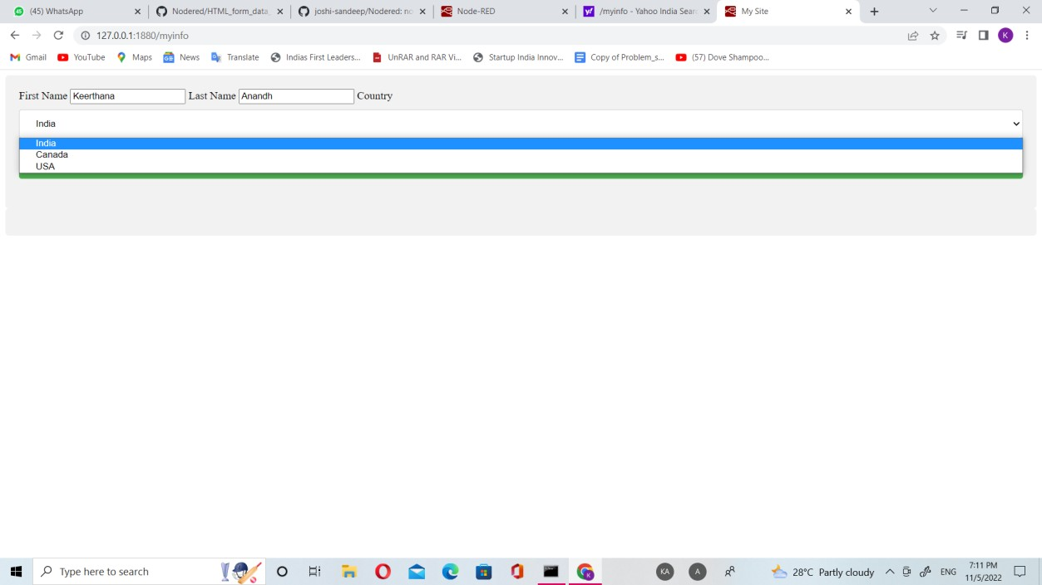

ENTRY FORM

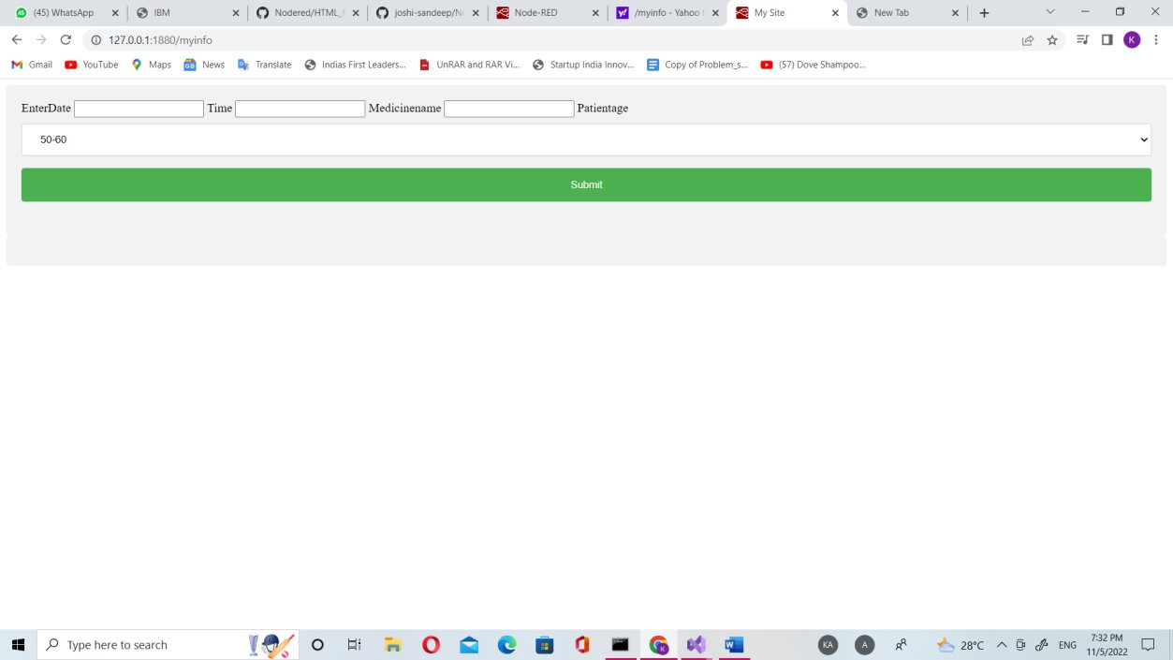

TO ENTER MEDICINE NAME AND DETAILS